5.Scenario: You are a data analyst working for a car manufacturing company. As part of your analysis, you have a dataset containing information about the fuel efficiency of different car models. The dataset is stored in a NumPy array named fuel_efficiency, where each element represents the fuel efficiency (in miles per gallon) of a specific car model. Your task is to calculate the average fuel efficiency and determine the percentage improvement in fuel efficiency between two car models.

Question: How would you use NumPy arrays and arithmetic operations to calculate the average fuel efficiency and determine the percentage improvement in fuel efficiency between two car models?

CODE:

import pandas as pd

import numpy as np

df = pd.read_csv(r'C:\Users\hp\Desktop\car_models_fuel_efficiency.csv')

fuel_efficiency = df['Fuel_Efficiency_MPG'].to_numpy()

average_efficiency = np.mean(fuel_efficiency)

print(f"Average fuel efficiency across all models: {average_efficiency:.2f} MPG")

model_a_index = 9

model_b_index = 49

model_a_efficiency = fuel_efficiency[model_a_index]

model_b_efficiency = fuel_efficiency[model_b_index]

percentage_improvement = ((model_b_efficiency - model_a_efficiency) / model_a_efficiency) * 100

print(f"Fuel efficiency of Model_10: {model_a_efficiency} MPG")

print(f"Fuel efficiency of Model_50: {model_b_efficiency} MPG")

print(f"Percentage improvement from Model_10 to Model_50: {percentage_improvement:.2f}%")

OUTPUT:

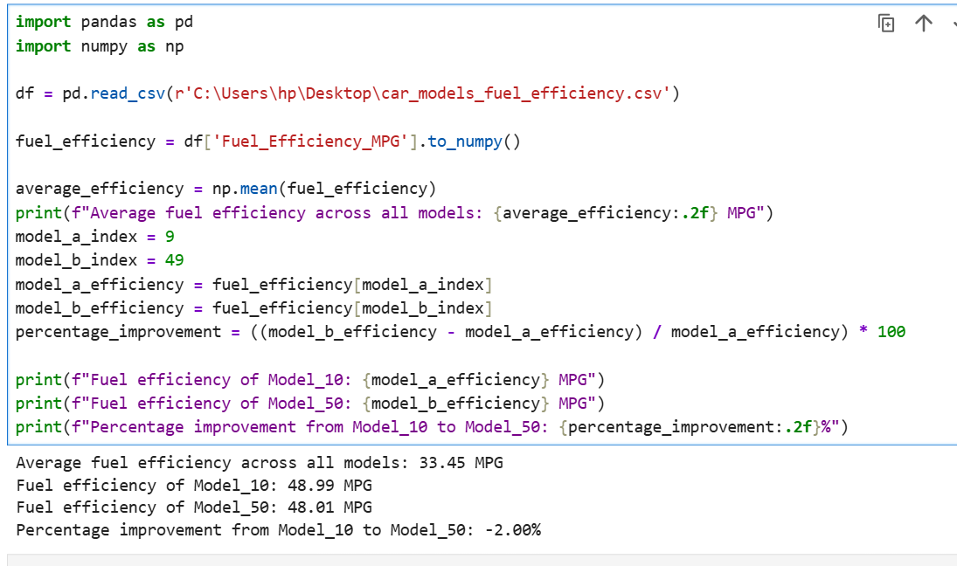

DATASET:

|  |  |  |  |
| --- | --- | --- | --- |
| Car_Model | Fuel_Efficiency_MPG | | |
| Model_1 | 24.56 |  |  |
| Model_2 | 33.29 |  |  |
| Model_3 | 45.78 |  |  |
| Model_4 | 19.45 |  |  |
| Model_5 | 41.83 |  |  |
| Model_6 | 39.67 |  |  |
| Model_7 | 29.38 |  |  |
| Model_8 | 36.22 |  |  |
| Model_9 | 23.58 |  |  |
| Model_10 | 48.99 |  |  |
| Model_11 | 17.82 |  |  |
| Model_12 | 44.67 |  |  |
| Model_13 | 31.75 |  |  |
| Model_14 | 21.48 |  |  |
| Model_15 | 26.95 |  |  |
| Model_16 | 42.63 |  |  |
| Model_17 | 37.28 |  |  |
| Model_18 | 47.05 |  |  |
| Model_19 | 16.43 |  |  |
| Model_20 | 28.41 |  |  |
| Model_21 | 30.87 |  |  |
| Model_22 | 25.44 |  |  |
| Model_23 | 22.01 |  |  |
| Model_24 | 32.54 |  |  |
| Model_25 | 27.18 |  |  |
| Model_26 | 43.12 |  |  |
| Model_27 | 20.74 |  |  |
| Model_28 | 49.33 |  |  |
| Model_29 | 46.85 |  |  |
| Model_30 | 34.98 |  |  |
| Model_31 | 19.62 |  |  |
| Model_32 | 38.2 |  |  |
| Model_33 | 40.72 |  |  |
| Model_34 | 45.13 |  |  |
| Model_35 | 29.84 |  |  |
| Model_36 | 33.5 |  |  |
| Model_37 | 18.29 |  |  |
| Model_38 | 25.96 |  |  |
| Model_39 | 31.11 |  |  |
| Model_40 | 47.68 |  |  |
| Model_41 | 36.77 |  |  |
| Model_42 | 44.33 |  |  |
| Model_43 | 22.96 |  |  |
| Model_44 | 27.62 |  |  |
| Model_45 | 23.73 |  |  |
| Model_46 | 35.44 |  |  |
| Model_47 | 30.35 |  |  |
| Model_48 | 26.84 |  |  |
| Model_49 | 21.09 |  |  |
| Model_50 | 48.01 |  |  |
| Model_51 | 32.76 |  |  |
| Model_52 | 37.19 |  |  |
| Model_53 | 43.88 |  |  |
| Model_54 | 19.07 |  |  |
| Model_55 | 27.81 |  |  |
| Model_56 | 40.94 |  |  |
| Model_57 | 38.48 |  |  |
| Model_58 | 31.55 |  |  |
| Model_59 | 24.18 |  |  |
| Model_60 | 49.72 |  |  |
| Model_61 | 17.61 |  |  |
| Model_62 | 45.5 |  |  |
| Model_63 | 34.15 |  |  |
| Model_64 | 28.33 |  |  |
| Model_65 | 36.94 |  |  |
| Model_66 | 42.07 |  |  |
| Model_67 | 47.94 |  |  |
| Model_68 | 29.11 |  |  |
| Model_69 | 21.67 |  |  |
| Model_70 | 39.2 |  |  |
| Model_71 | 33.76 |  |  |
| Model_72 | 41.59 |  |  |
| Model_73 | 26.33 |  |  |
| Model_74 | 22.79 |  |  |
| Model_75 | 44.88 |  |  |
| Model_76 | 37.86 |  |  |
| Model_77 | 19.88 |  |  |
| Model_78 | 30.04 |  |  |
| Model_79 | 24.61 |  |  |
| Model_80 | 48.55 |  |  |
| Model_81 | 32.12 |  |  |
| Model_82 | 46.21 |  |  |
| Model_83 | 35.66 |  |  |
| Model_84 | 20.29 |  |  |
| Model_85 | 27.05 |  |  |
| Model_86 | 38.82 |  |  |
| Model_87 | 43.41 |  |  |
| Model_88 | 31.3 |  |  |
| Model_89 | 23.2 |  |  |
| Model_90 | 49.05 |  |  |
| Model_91 | 18.43 |  |  |
| Model_92 | 45 |  |  |
| Model_93 | 34.62 |  |  |
| Model_94 | 28.05 |  |  |
| Model_95 | 36.49 |  |  |
| Model_96 | 41.28 |  |  |
| Model_97 | 47.4 |  |  |
| Model_98 | 29.54 |  |  |
| Model_99 | 20.87 |  |  |
| Model_100 | 39.88 |  |  |
|  |  |  |  |